Step 1: Create New Vendor

Submit the screen shot of Create Vendor: Correspondence Accounting screen (2.5 points)

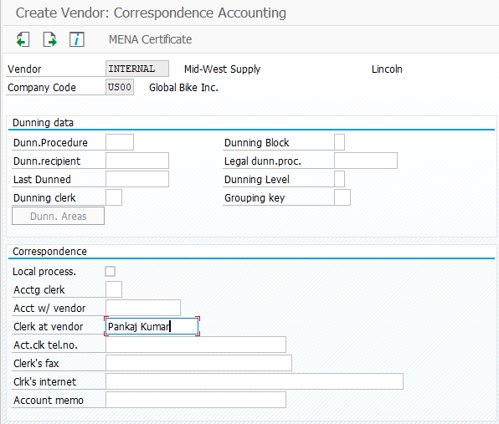

Step 2: Create Material Master for Trading Goods

Submit the screen shot with the Accounting 1 tab displayed (2.5 points)

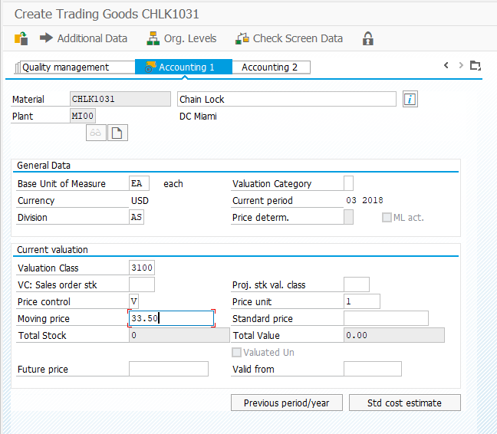

Step 3: Extend Material Master for Trading Goods

Submit the screen shot after entering Scale quantity 1 and amount 65.00 (2.5 points)

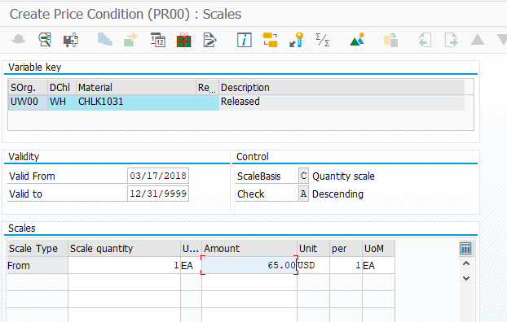

Step 4: Display Stock/Requirements List

No screenshot required.

Step 5: Create Purchase Requisition

Submit the screen shot of the dialog box showing the purchase requisition number created (2.5 points)

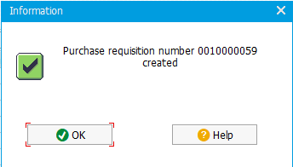

Step 6: Display Stock/Requirements List

Submit the screen shot showing Stock/requirements List (2.5 points)

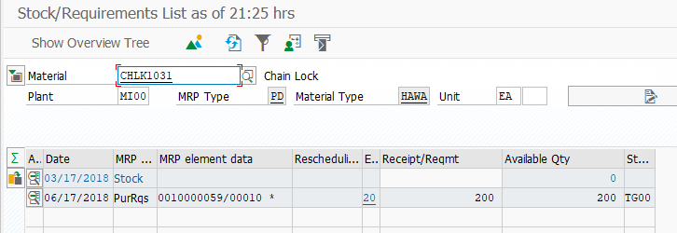

Step 7: Create Request for Quotation

Submit the screen shot showing the Selection of Purchase Requisitions (2.5 points)

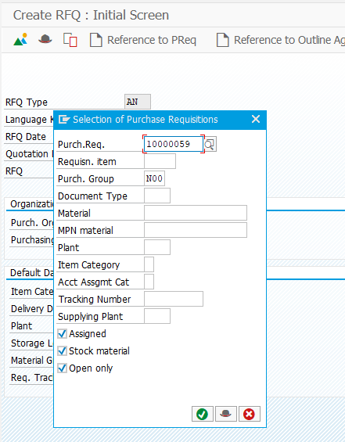

Submit the screen shot of the dialog box showing the RFQ document number (2.5 points)

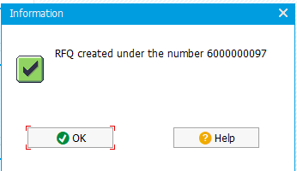

Submit the screen shot of the Vendor Address Screen for Dallas Bike Basics (2.5 points)

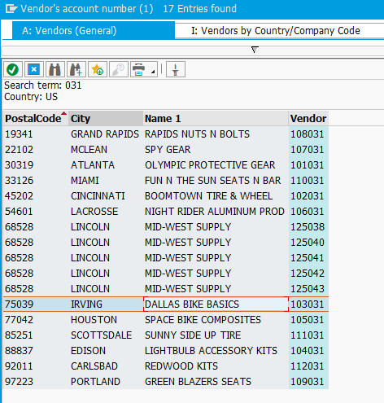

Step 8: Maintain Quotations from Vendors

Submit the screen shot for Dallas Bike Basics when you repeat this for the other RFQs (2.5 points)

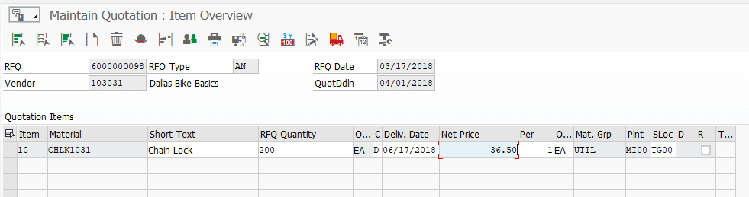

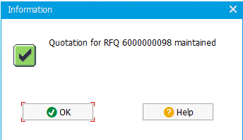

Step 9: Evaluate quotations on price

Submit the screen shot showing the summary of the three quotations (2.5 points)

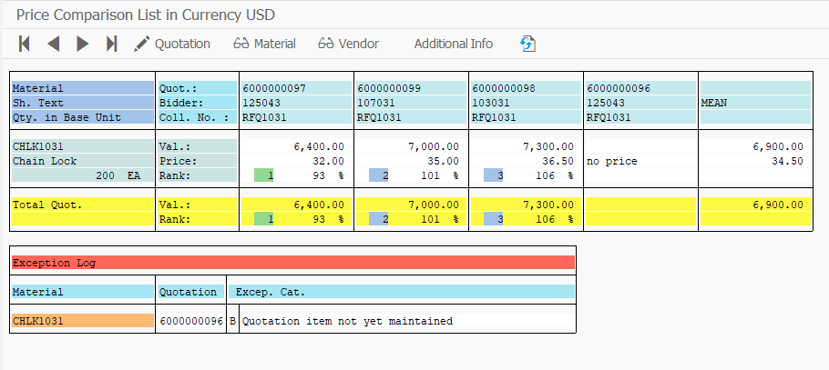

Step 10: Create Purchase Order Referencing an RFQ  
 Submit the screen shot showing above screen (2.5 points)

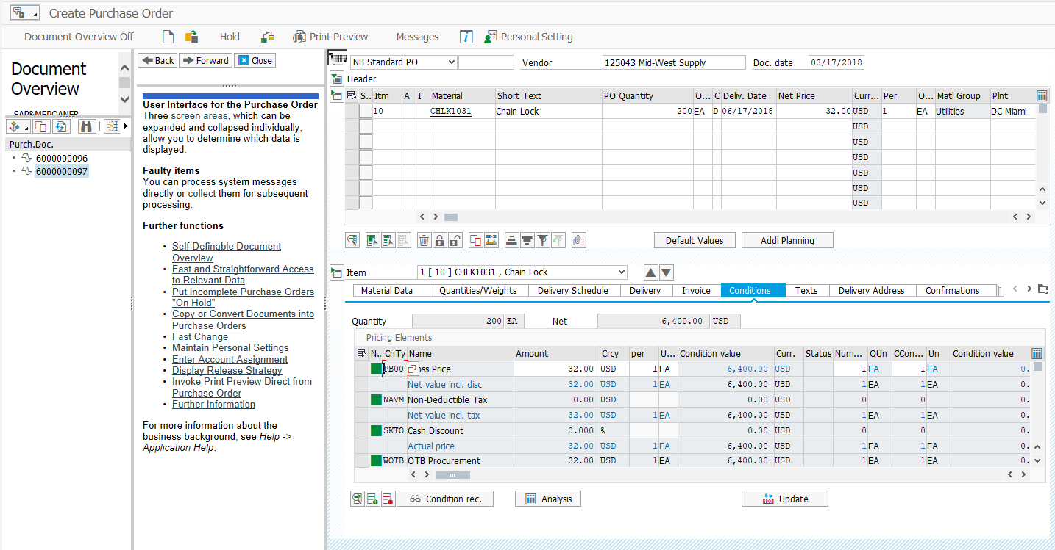

Step 11: Display Purchase Order

Submit the purchase order (5 points)

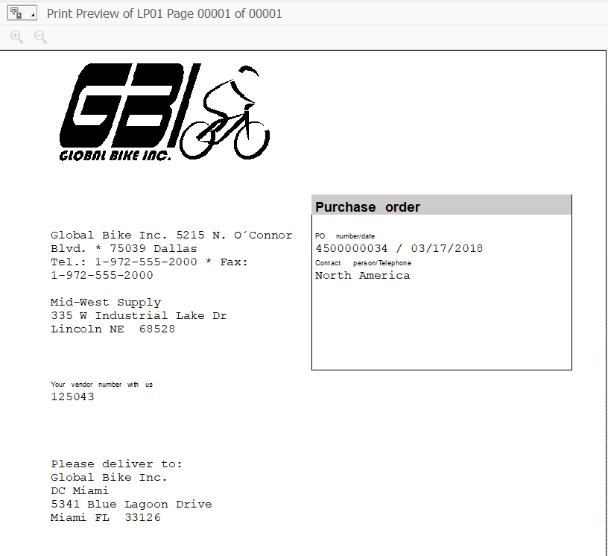

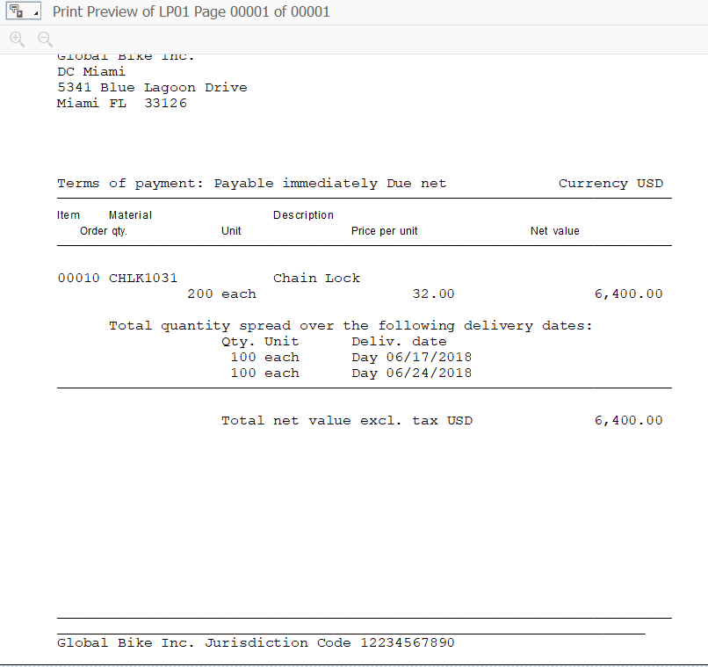

Step 12: Create Goods Receipt for Purchase Order

Submit the screen shot showing the General tab screen (2.5 points)

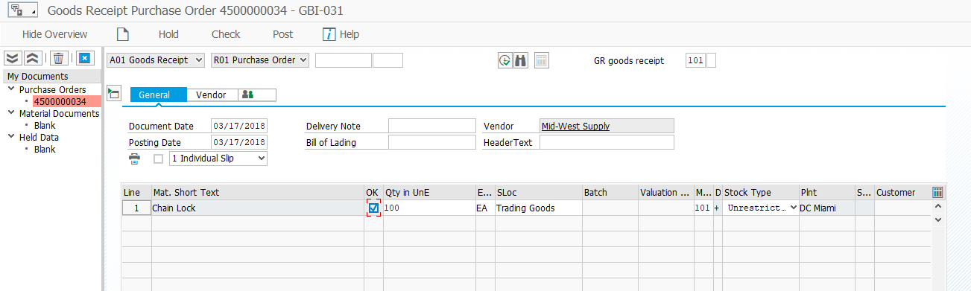

Step 13: Verify Physical Receipt of Goods

Submit the screen shot showing the inventory (2.5 points)

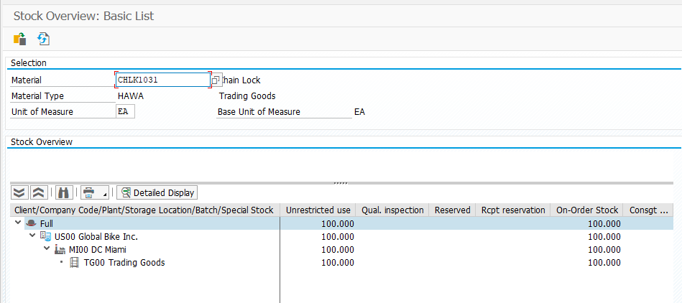

Submit the screen shot of Stock Overview: Basic List (2.5 points)

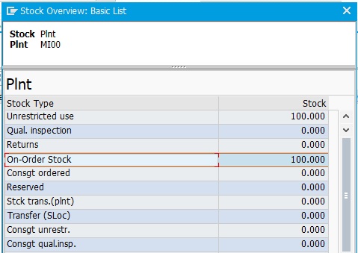

Step 14: Create Invoice Receipt from Vendor

Submit the screen shot of Enter Incoming Invoice (2.5 points)

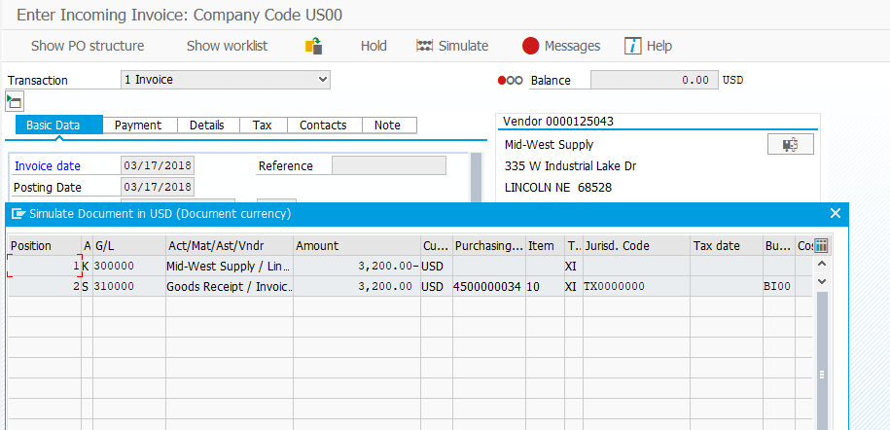

Step 15: Display Purchase Order History

Submit the material document (2.5 points).

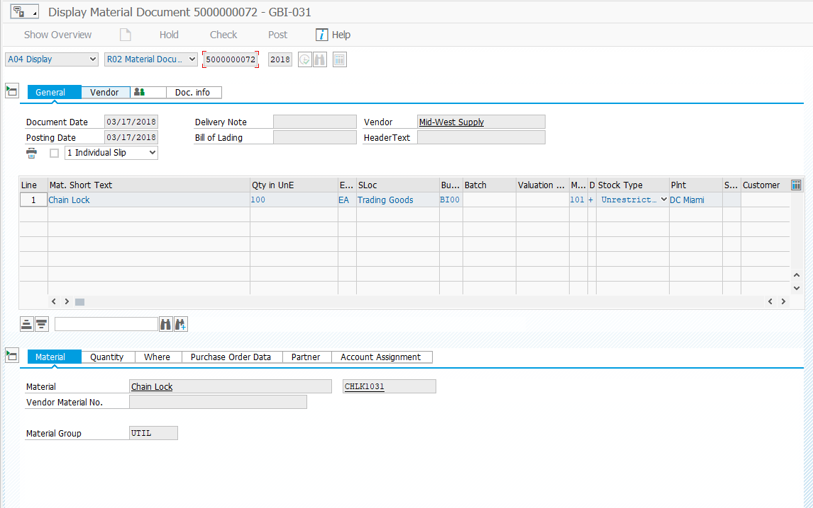

Submit the General Ledger Posting (2.5 points).

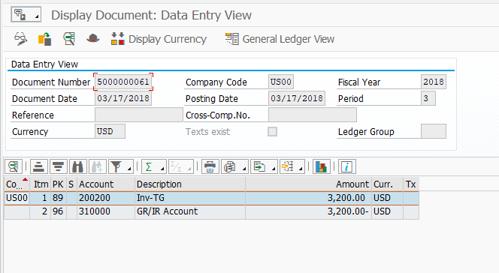

Submit the invoice document (2.5 points)

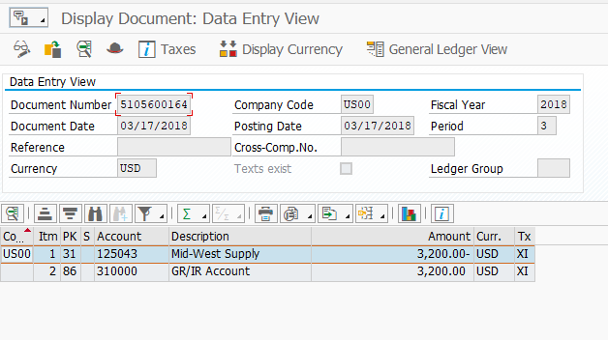

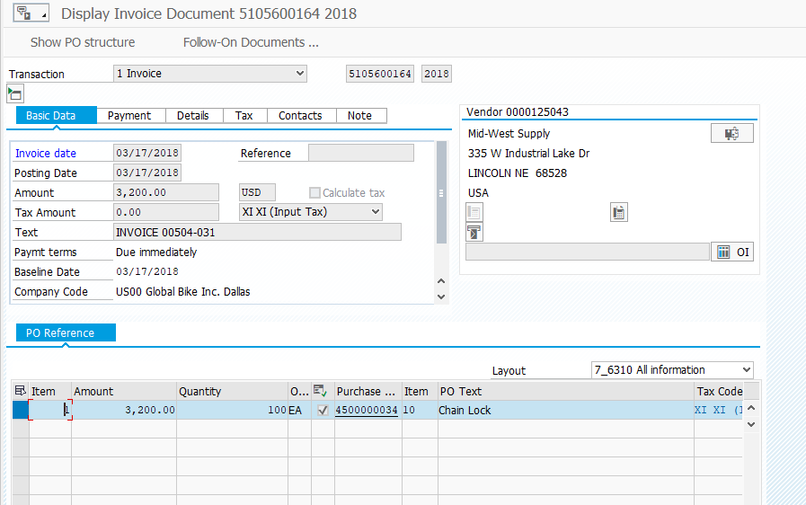

Step 16: Create Goods Receipt for Purchase Order

No screenshot required.

Step 17: Create Invoice Receipt from Vendor

Submit the screen shot of invoice receipt (2.5 points).

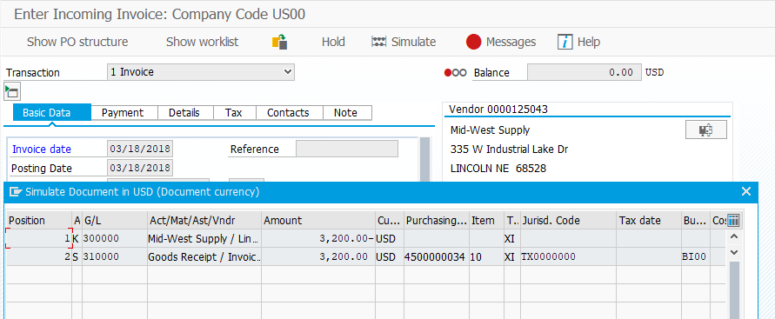

Step 18: Post Payments to Vendor

Submit the screen shot of Processing Status screen (2.5 points).

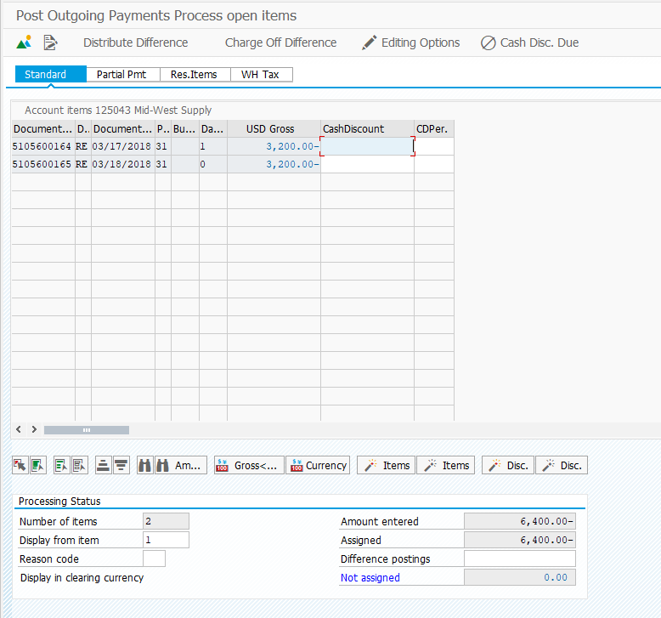

Step 19: Display Vendor Line Items

Submit the screen shot of Bals tab screen (2.5 points).

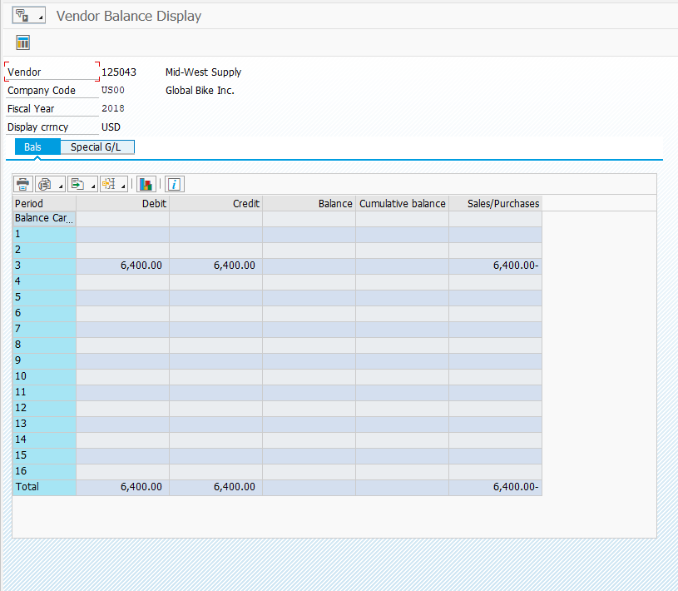

Step 20: Display Purchase Order History

Submit the screen shot of the Purchase Order History tab screen (2.5 points).

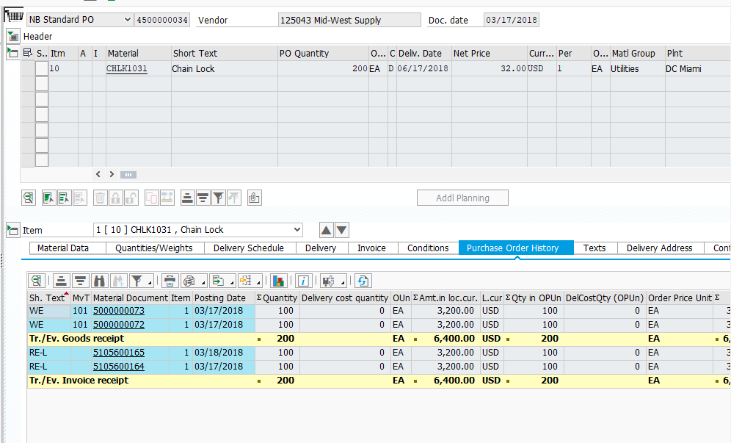

Submit the screen shot of the General Ledger posting (2.5 points)

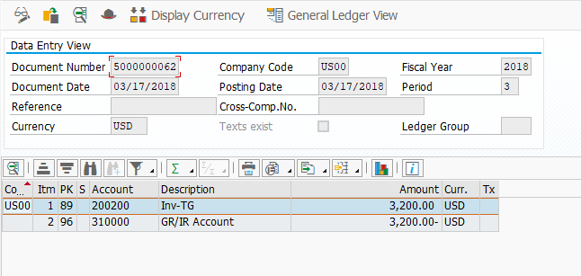

Submit the screen shot of the General Ledger posting (2.5 points)

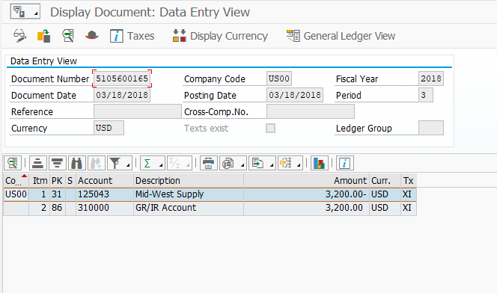

Step 21: Display/Review G/L Account Balances and Individual Line Items

Submit the screen shot of the General Ledger account balance history screen (2.5 points)

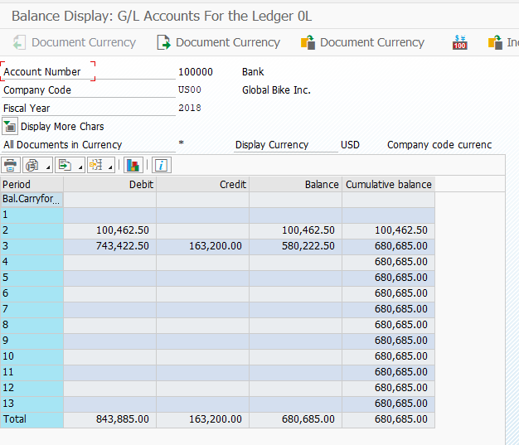

Submit the screen shot of the General Ledger Line Items: Display for your user id (2.5 points)

